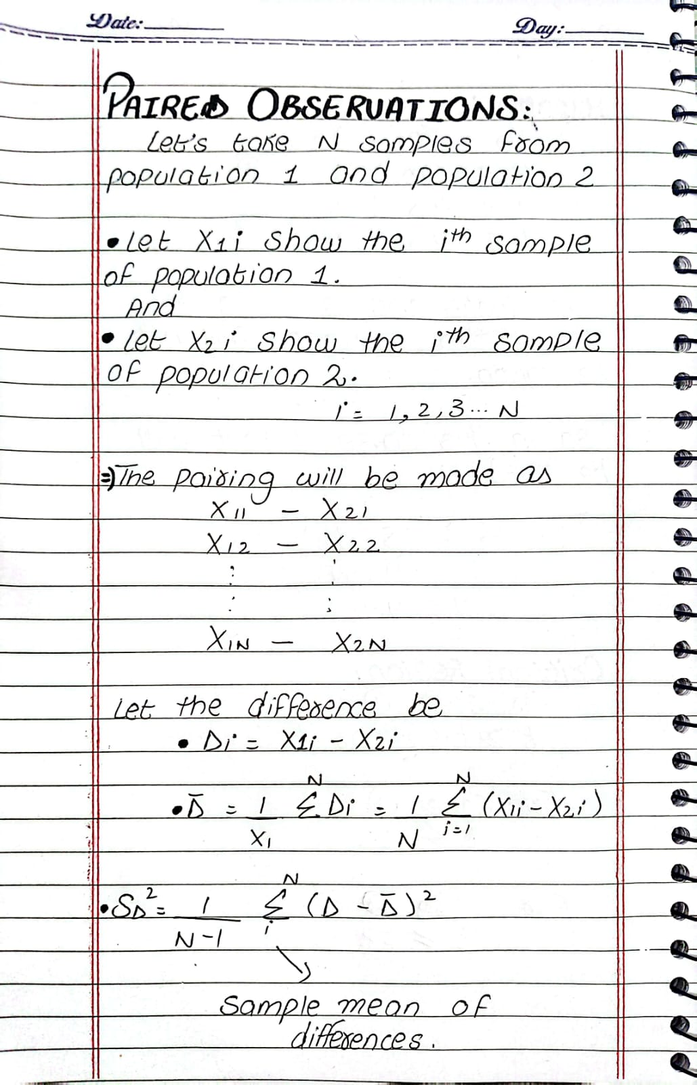

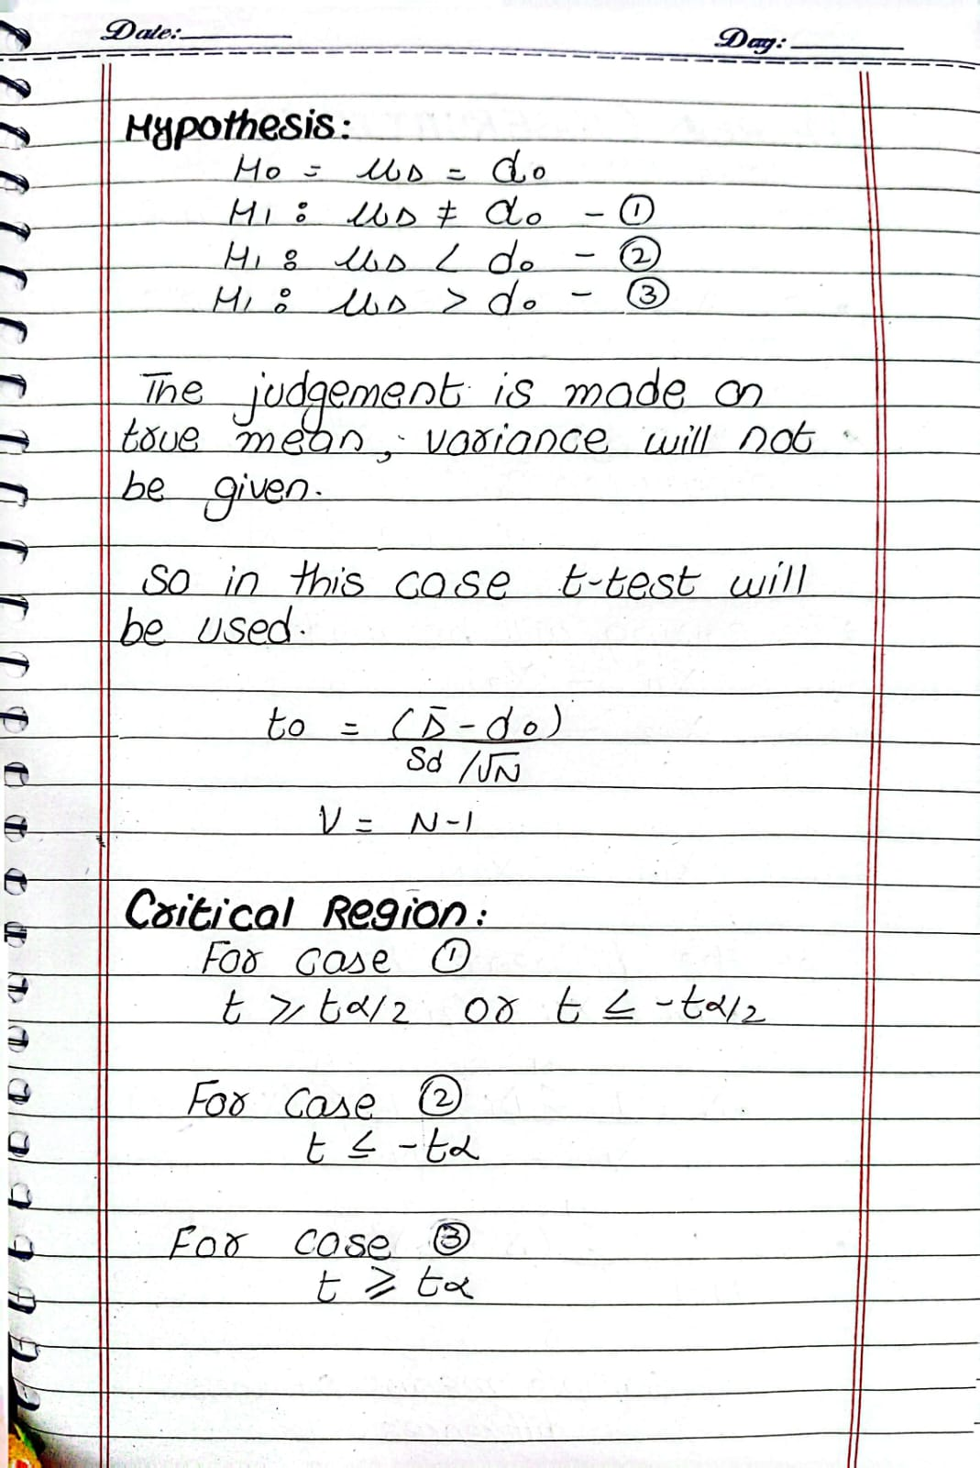

Question: Paired Sample t-Test
A researcher conducted a study on 15 wild deer to examine whether the drug succinylcholine affects androgen levels in their blood. Androgen levels (in ng/mL) were measured before and 30 minutes after the injection. The following summary statistics were obtained for the differences in androgen levels (After - Before):
- Sample Mean Difference (d̄): 9.848
- Sample Standard Deviation (sₑ): 18.474
- Sample Size (n): 15
- Significance Level (α): 0.05
Using a paired sample t-test, test whether there is a significant change in androgen levels after the injection.
Should the null hypothesis be rejected?

